

38th Annual Oregon-California Trails Convention

Elko, NV * September 12 – 16, 2021

*“Through the Lens of History – Preserving the Past – Focusing on the Future”*

**KEY DATES**

|  |  |
| --- | --- |
| Saturday, September 11  Sunday, September 12 | Pre-Convention Tours  “California Trail Highlights” (Burley ID to Elko NV – 2 days)  “Lamoille Canyon Photography, Geology and Natural History Tour”  Greenhorn Cutoff Hike with Dick Waugh  OCTA National Board Meeting – California Trail Interpretive Center  Welcome Reception – California Trail Interpretive Center |
| Monday, September 13 | Welcome and Opening Session  Speakers |
| Tuesday – September 14 | Bus Tours  - Fort Ruby and Ruby Valley  - Guns and Ruts  - Long Canyon Mine Project  - Gravelly Ford  Private Vehicle Tour  “The Humboldt is North of Us…So Let’s Go South”  “Ancient Pronghorn Antelope Van Tour” (ONLY on Tuesday) |
| Wednesday, September 15 | Speakers  Activity Stations at Convention Center |
| Thursday, September 16 | Repeat of Tuesday tours |

**Private vehicle tours**

- “The Humboldt River is north of us…so let’s go south” – led by Roger Gash  
- “California Trail Highlights – City of Rocks to Goose Creek” – led by Paul Dinwiddie (2 day tour)

- “Ancient Pronghorn Antelope Tour”

**Make Your Room Reservations Now for the Best Value!**

- High Desert Inn - $59 - 775.738.8425

- Gold Country Inn - $69 - 775.738.8421

- Red Lion Hotel & Casino - $79 - 775.738. 2111

OCTA DISCOUNT NAME - OCTA Oregon California Trail Convention 2020

**KEYNOTE SPEAKERS**

|  |  |
| --- | --- |
| **Dr. James Armstead, Keynote Speaker** | **“The Socio-Political Origins of the Western Migration”** |
| **Dr. Sue Fawn Chung, Keynote Speaker** | **“The Chinese Railroad Workers on the Central** |

**NEW ATTRACTIONS AT 2021 CONVENTION**

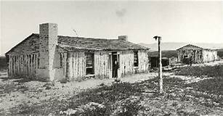**Fort Ruby, Ruby Valley, Nevada**

In Ruby Valley, just east of Overland Pass, are the remains of Fort Ruby. The Fort (1862-9) was built by the U.S. Army in the "wilderness of eastern Nevada." to protect the overland mail coaches, Pony Express and emigrant trail. Excavated jointly by the U.S. Forest Service and U.S. Fish and Wildlife Service after 2002, the site now boasts about ½ mile of interpretive trail with eleven interpretive panels and a reconstructed spring house.

**The Williams Family Gun Museum, Blacksmith Shop and Gunsmith Shop**

More than 1200 firearms – many that were guns that were used to settle the American West – make up the extraordinary collection of Jeff Williams and his family. The museum boasts examples of almost every type of fire arm from the Revolutionary War to the present. There are many other historical artifacts in the museum in addition to the amazing array of weapons. Immediately adjacent to the gun museum, Jeff has constructed a period-correct 19th century blacksmith shop, with an antique trip hammer, and gunsmith shop.

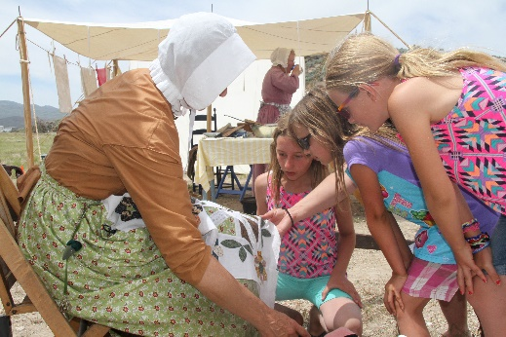**California Trail Days at the California Trail Interpretive Center**

During Trail Days on Saturday September 19, 2020, you can refresh your recollections or learn the stories of the pioneers who endured the 2,000-mile trek to California.

Between 1841 and 1869 over 250,000 people sold their belongings, packed up wagons and set out over-land for California.

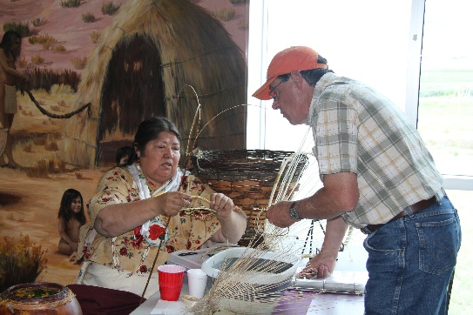Some were seeking land. Others were searching for gold. Still others sought adventure. Some went for reasons we may never know.

Enjoy Native American programs, visit with fur trappers and watch black powder demonstrations. Our young visitors will enjoy Jr. Ranger activities throughout the camp. California Trail Days is a

pioneer reenactment event for the whole family.

**Lamoille Canyon**

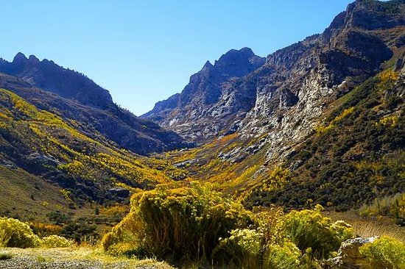Learn about the natural history, geology, and tips on photography in the beautiful Ruby Mountains located southeast of Elko, NV. Regionally known photographer and geologist Susan Elliott and naturalist Larry Hyslop will lead a never-to-be-forgotten bus tour of the Canyon with stops for a short nature walk and photography. The glaciated and geologically varied “Rubies” are a true treasure in Northern Nevada’s desert environment.

Ancient Pronghorn (Antelope) Trap Tour

Native Americans were experts when it came to knowing the habits of wild game and how to best hunt, track and trap them. Some animals such as pronghorn were successfully taken during communal hunts where herds of animals were driven into corrals measuring as much as half a mile in diameter. The walls of the corrals were typically made of juniper limbs and trunks. Elko County has among the largest number of existing aboriginal pronghorn traps in the western United States. Evidence suggests that communal hunting in our area began as early as 3500 to 5000 years ago. The tour will be to one of the best preserved traps in northeast Nevada.